SYDNEY WESTERN CITY PLANNING PANEL

Panel Number: | PPS-2018SSW033
Application Number: | 2018/969/1.
Local Government Area: | Camden.
Development: | Demolition of the existing entry road, community title subdivision to create 73 lots (69 dwelling lots, three superlots for the residential flat buildings and one community lot for the park), construction of 69 dwellings and three residential flat buildings containing 90 apartments, associated earthworks, construction of local roads, drainage works, neighbourhood park / piazza, including community facilities (pool, community building, BBQ and children’s playground) landscaping works and acoustic upgrade works to Lakeside Golf Club Camden.
Capital Investment Value: | $72,762,086
Site Address(es): | 900 Camden Valley Way & 50 Raby Road, Gledswood Hills
Applicant: | SH Camden Lakeside Pty Ltd C/O SJB Planning
Owner(s): | SH Camden Lakeside Pty Ltd & Narellan Property Holdings
Date of Lodgement: | 8 August 2018
Number of Submissions: | Nil.
Number of Unique Objections: | Nil.
Classification: | Regionally significant and integrated development.
Recommendation: | Approve with conditions.
Regional Development Criteria (Schedule 7 of State Environmental Planning Policy (State and Regional Development) 2011): | General development capital investment value >$30 million.
List of All Relevant Section 4.15(1)(a) Matters: | - State Environmental Planning Policy (State and Regional Development) 2011.  - State Environmental Planning Policy (Infrastructure) 2007.  - State Environmental Planning Policy No. 55 - Remediation of Land.  - State Environmental Planning Policy No. 65 – Design Quality of Residential Apartment Development  - State Environmental Planning Policy (Building Sustainability Index: BASIX) 2004  - Sydney Regional Environmental Plan No 20 - Hawkesbury-Nepean River.  - Camden Local Environmental Plan 2010  - Camden Development Control Plan 2011 & 2019.
List all Documents Submitted with this Report for the Panel’s Consideration: | - Assessment report.  - Applicant’s written request seeking to justify the contravention of a development standard.  - Apartment Design Guide Assessment Table.  - Camden Local Environmental Plan 2010 Assessment Table.  - Camden Development Control Plan 2011 Assessment Table.  - Recommended conditions.  - Proposed plans.
Development Standard Contravention Request(s): | Camden Local Environmental Plan 2010.  Clause 4.3 - Maximum building height.
Summary of Key Submission Issues: | Nil
Report Prepared By: | Adam Sampson, Executive Planner.
Report Date: | October 2020.

Summary of Section 4.15 Matters

Yes
Have all recommendations in relation to relevant Section 4.15 matters been summarised in the Executive Summary of the assessment report?

Legislative Clauses Requiring Consent Authority Satisfaction

Yes
Have relevant clauses in all applicable environmental planning instruments where the consent authority must be satisfied about a particular matter been listed and relevant recommendations summarised in the Executive Summary of the assessment report?

Development Standard Contraventions

 | Yes | N/A
If a written request for a contravention to a development standard has been received, has it been attached to the assessment report?

Special Infrastructure Contributions

 | Yes | No
Does the application require Special Infrastructure Contributions?

Conditions

Yes
Have draft conditions been provided to the applicant for comment?

PURPOSE OF REPORT

The purpose of this report is to seek the Sydney Western City Planning Panel’s (the Panel’s) determination of a development application (DA) for the demolition of the existing entry road, community title subdivision to create 73 lots (69 dwelling lots, three superlots for the residential flat buildings and one community lot for the park), construction of 69 dwellings and three residential flat buildings containing 90 apartments, associated earthworks, construction of local roads, drainage works, neighbourhood park / piazza, including community facilities (pool, community building, BBQ and children’s playground) landscaping works and acoustic upgrade works to Lakeside Golf Club Camden at 900 Camden Valley Way and 50 Raby Road, Gledswood Hills.

The Panel is the consent authority for this DA as the capital investment value (CIV) of the development is $72,762,086. This exceeds the CIV threshold of $30 million for Council to determine the DA pursuant to Schedule 7 of State Environmental Planning Policy (State and Regional Development) 2011.

SUMMARY OF RECOMMENDATION

That the Panel support the justification in the applicant’s written request lodged pursuant to Clause 4.6(3) of Camden Local Environmental Plan 2010 to the contravention of the height of buildings development standard and approve DA/2018/969/1 for demolition of the existing entry road, community title subdivision to create 73 lots (69 dwelling lots, three superlots for the residential flat buildings and one community lot for the park), construction of 69 dwellings and three residential flat buildings containing 90 apartments, associated earthworks, construction of local roads, drainage works, neighbourhood park / piazza, including community facilities (pool, community building, BBQ and children’s playground) landscaping works and acoustic upgrade works to Lakeside Golf Club Camden pursuant to Section 4.16 of the Environmental Planning and Assessment Act, 1979 by granting consent subject to the conditions attached to this report.

EXECUTIVE SUMMARY

Council is in receipt of a DA for the demolition of the existing entry road, community title subdivision to create 73 lots (69 dwelling lots, three superlots for the residential flat buildings and one community lot for the park), construction of 69 dwellings and three residential flat buildings containing 90 apartments, associated earthworks, construction of local roads, drainage works, neighbourhood park / piazza, including community facilities (pool, community building, BBQ and children’s playground) landscaping works and acoustic upgrade works to Lakeside Golf Club Camden at 900 Camden Valley Way and 50 Raby Road, Gledswood Hills.

The DA has been assessed against the Environmental Planning and Assessment Act 1979, the Environmental Planning and Assessment Regulation 2000, relevant environmental planning instruments, development control plans and policies.

A summary of the assessment of all relevant environmental planning instruments is provided below with a detailed assessment provided later in the report.

State Environmental Planning Policy (State and Regional Development) 2011. | The Panel is the consent authority for this DA as the development has a CIV of $72,762,086 which exceeds the CIV threshold of $30 million for Council to determine the DA.
State Environmental Planning Policy No 55 - Remediation of Land. | Council staff have assessed a contamination assessment of the access road constructed of asphalt and tar leading from Raby Road to the Camden Lakeside Golf Club.  The contamination assessment found that results of soil sampling undertaken from boreholes drilled into the access road are below the relevant criteria. As such, Council staff are satisfied that no remediation is required in this instance and that the site is suitable for the development.
State Environmental Planning Policy No. 65 – Design Quality of Residential Apartment Development | The development is largely consistent with the Design Quality Principles and the Apartment Design Guide.
State Environmental Planning Policy (Building Sustainability Index: BASIX) 2004. | The applicant has submitted a valid BASIX Certificate in support of the DA that demonstrates that water, thermal comfort and energy requirements have been achieved.
State Environmental Planning Policy (Infrastructure) 2007 (ISEPP). | The DA was referred to the RMS and to Transgrid for comment pursuant to the ISEPP and comments and recommended conditions received have been considered.
Sydney Regional Environmental Plan No 20 - Hawkesbury-Nepean River (No.2 – 1997) | The development is consistent with the aim of SREP 20 (to protect the environment of the Hawkesbury-Nepean River system) and all of its planning controls.
Camden Local Environmental Plan 2010 | The development is permitted with consent in the applicable R1 – General Residential and E2 – Environmental Conservation zones and is consistent with the objectives of the zones and acceptable in terms of the LEP’s other matters for consideration.

The DA was publicly exhibited for a period of 14 days in accordance with Camden Development Control Plan 2011. The exhibition period was from 14 September 2018 to 27 September 2018 and one objection and one submission in support was received.

Following the submission of amended plans and additional information, the DA was publicly re-exhibited for a period of 17 days in accordance with Camden Development Control Plan 2019. The re-exhibition period was from 7th January 2020 to 24th January 2020 and one objection and one submission in support was received. The submission of objection against the proposed development was later withdrawn.

The application proposes a contravention to the maximum height of buildings development standard as prescribed under Clause 4.3(2) of Camden Local Environmental Plan (CLEP) 2010. CLEP 2010 limits the maximum height of buildings to 9.5m (J) and 12.5m (M) above ground level (existing) upon this site. Six dwellings upon lots 18, 20, 21, 23, 24 and 25, which are located within the height of buildings map of 9.5m, will breach the development standard. The contraventions range from 365mm to 2.472m. The contravention is assessed in detail in this report and is supported by Council staff.

In addition, the applicant proposes variations to front and secondary setbacks, rear setbacks, rear lane setbacks, landscaping, zero lot line development, solar access and density. These variations are assessed in further detail in this report and are supported by Council staff.

Based on the assessment, it is recommended that the DA be approved subject to the conditions attached to this report.

KEY PLANNING CONTROL VARIATIONS

Control | Proposed | Variation
9.5m maximum building height | The contraventions range from 365mm to 2.472m. | 365mm – 2.472m (3.8% to 26%)
Front and Secondary setbacks (Dwelling Lots – Front setbacks Minimum 4.5m Secondary setbacks lots > 450m² 3m minimum) (RFB – Secondary setbacks Minimum 6m) | Dwelling Lots  Front setbacks – 2m  Secondary setbacks – 2.876m  Residential Flat Buildings  Secondary setbacks – 5.2m to 5.644m | Dwelling lots  Front – 2m  Secondary – 124mm  RFBs  356mm – 800mm
Rear Setbacks (6m) | 1.5m to 5.839m | 161mm – 4.5m
Rear Lane Setbacks (2.5m min) | 0.5m to 2.1m | 0.4m – 2m
Landscaping (min 30% of site area) | 26% to 4 lots | 13.3%
Zero lot line development (10m maximum) | 10.4m to 14m. | 0.4 – 4m
Solar Access (min 2 hours to at least 50% of the PPOS between 9.00am and 3.00pm on 21 June) | < 2 hours achieved to four lots. | < 2 hours achieved
Density (shall not exceed 1 unit per 200m² of site area) | Lot 65 – South Apartment – 136.7m² per dwelling  Lot 70 – East Apartment – 117.1m² per dwelling  Lot 71 – West Apartment – 132.3m² per dwelling | 31.65%  41.45%  33.85%

AERIAL PHOTO

THE SITE

The site is commonly known as 900 Camden Valley Way and 50 Raby Road, Gledswood Hills and is legally described as Lot 70 DP 1261166 and Part Lot 71 DP 1261166 and has an overall area of 34.27 hectares. The development site is currently devoid of any structures, with scattered trees adjoining the existing entry road from Raby Road. The site is partially mapped as bush fire prone land.

Subdivision and construction works are proposed to occur wholly within 900 Camden Valley Way, Gledswood Hills. Development works within 50 Raby Road, Gledswood Hills are limited to acoustic upgrades to Lakeside Golf Club Camden and the creation of an 8m Asset Protection Zone to the south west of proposed lots 6 – 12, which will be shared by the development lot and the Golf Course land.

The overall site is irregular in shape, with the area of development adjacent to the southern side of Raby Road shaped like an arrowhead. The area of development for Camden Lakeside Precinct 1 is 6.34 hectares with the site having a frontage of 279.36 metres to Raby Road. The land has a cross fall from the rear of the site towards the north and Raby Road. The development site is an urban release area pursuant to Camden Local Environmental Plan 2010 and is subject to a voluntary planning agreement with the Minister for Planning for the purposes of contributions for the provision of designated State public infrastructure before the subdivision of land.

The surrounding locality to the north (Emerald Hills), south east (The Crest) and the south west (El Caballo Blanco) is currently undergoing transformation to residential subdivision development.
To the north of the site, opposite Raby Road, the Emerald Hills Neighbourhood Centre exists. To the south, the Camden Lakeside Clubhouse and golf course exists. To the west, the continuation of the Camden Lakeside golf course exists.

To the east of the site, Transgrid Electrical transmission structures exist. The site is approximately 230 metres from the intersection of Camden Valley Way / Raby Road to the north west.

ZONING PLAN

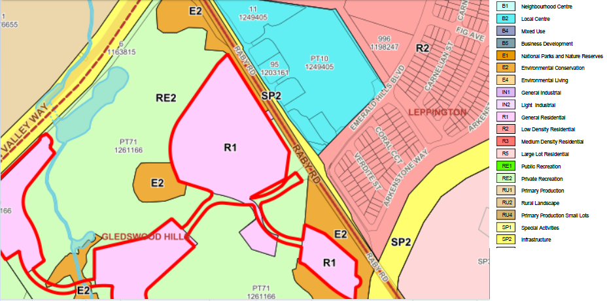

CAMDEN LAKESIDE MASTER PLAN

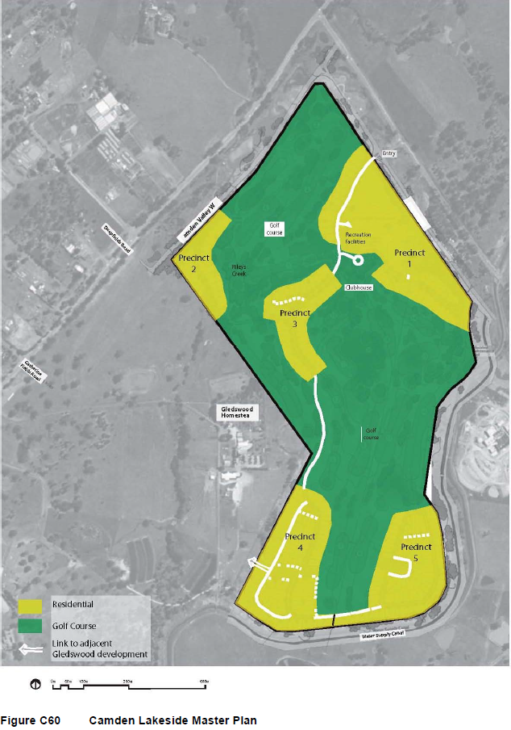

HISTORY

The relevant development history of the site is summarised in the following table:

Date | Development
14 December 2010 | Construction and dedication of new entrance road subject to DA/2010/967/1.
9 December 2011 | Demolition of car park, construction of new car park and associated site works subject to DA/2010/968/1.
5 August 2011 | Construction and dedication of roads, construction of earthworks, drainage, services and landscaping subject to DA/2010/1205/1.
31 May 2012 | Subdivision to create 2 superlots subject to DA/2010/1204/1.
1 September 2011 | Erection of 15 dwellings subject to DA/2010/1267/1.
7 April 2017 | Modification for boundary adjustment and to align with signalised intersection subject to DA/2010/967/2.
29 October 2018 | Modification to amend the internal road intersection alignment and associated landscaping of an approved entrance road subject to DA/2010/967/3.
17 July 2020 | Modification to amend road levels, road width, verge widths and associated landscaping subject to DA/2010/967/4.

THE PROPOSAL

DA/2018/969/1 seeks approval for the demolition of the existing entry road, community title subdivision to create 73 lots (69 dwelling lots, three superlots for the residential flat buildings and one community lot for the park), construction of 69 dwellings and three residential flat buildings containing 90 apartments, associated earthworks, construction of local roads, drainage works, neighbourhood park / piazza, including community facilities (pool, community building, BBQ and childrens playground) landscaping works and acoustic upgrade works to Lakeside Golf Club Camden.

The development will be developed under a community title scheme through the incorporation of a community association and will consist of three categories namely torrens title lots for detached and zero lot line dwellings; strata title lots for each of the residential flat buildings; and community title for the parks, piazza and landscaped areas.

Under the community title scheme, residents will remain responsible for the maintenance and repair of the community title Lot (Lot 1) and for the maintenance of the landscape verges within all roads dedicated to Council. The community title lot (Lot 1) will include all land and property outside the residential flat building lots (65, 70 and 71), public roads and all torrens titled lot boundaries. The residential flat buildings will be set up as a separate subsidiary strata scheme within the community title scheme, whereby additional by-laws and levies will be applied.

Specifically, the development involves:

- Demolition of the existing entry road;
- Bulk earthworks;
- Construction of new local roads:
- Provision of ancillary services, drainage works, landscaping works;
- Community title subdivision to create 73 lots (69 dwelling lots, three (3) superlots for the residential flat buildings and one (1) community lot for the park and landscaped areas);
- Construction of 69 dwellings across a range of dwelling topologies, including zero lot line and detached dwellings (dwelling lots range from 317m² to 693m²);
- Construction of three (3) residential flat buildings (RFBs), encompassing a total of 90 apartments. The RFB development, involves:

Construction of three (3) x three (3) storey residential flat buildings with one level of basement parking (each building) with a total of 90 units (30 units per each building) comprising;

Lot 65 – South Building

- 8 x 1 bedroom units, 10 x 2 bedroom units and 12 x 3 bedroom units

Lot 70 – East Building

- 9 x 1 bedroom units, 9 x 2 bedroom units and 12 x 3 bedroom units

Lot 71 – West Building

- 8 x 1 bedroom units, 10 x 2 bedroom units and 12 x 3 bedroom units

- Provision of neighbourhood park / piazza; and

- Provision of acoustic and architectural upgrade works for the function room at Lakeside Golf Club Camden, which includes installation of 16.78mm proprietary glazing system to function room spaces capable of achieving R_{w} 40 in addition to the octave band spectrum performance and upgrade of the existing internal ceiling to comprise new insulation in ceiling void (minimum thickness 200mm, minimum density 14kg/m³); new suspended ceiling grid with resilient changers (equivalent to Embelton type LHB); and new 2 x 16mm fire rated plasterboard ceiling.

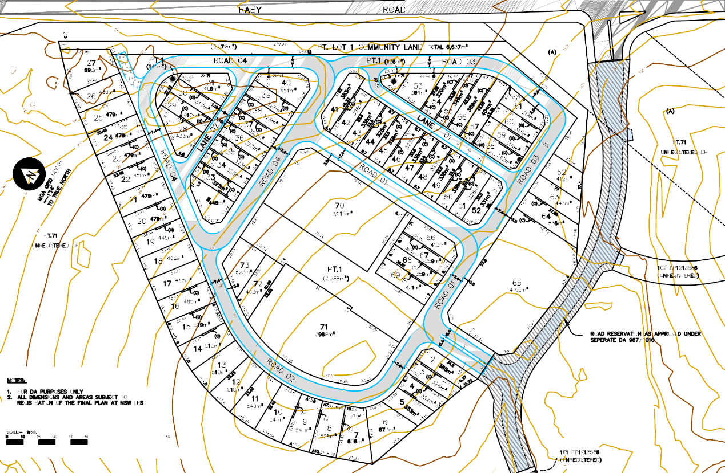
Image 1 – Plan of Subdivision

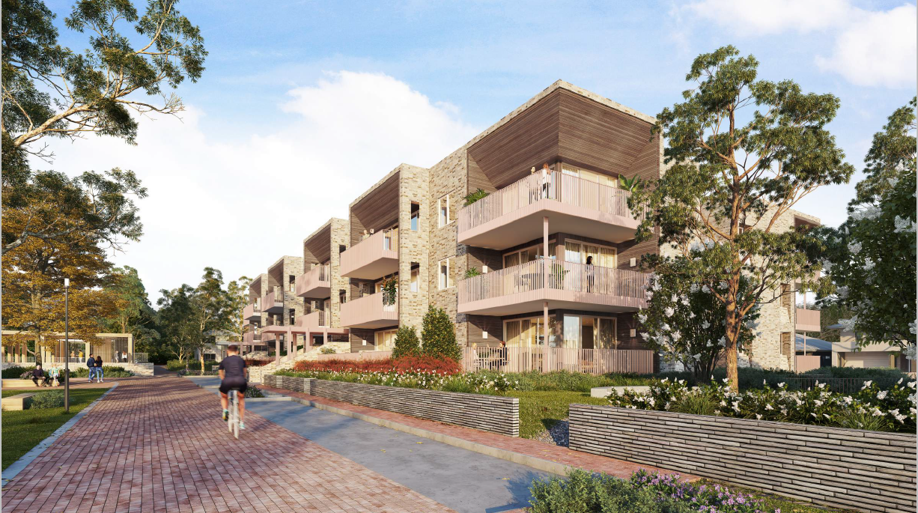
Image 2 – East Apartment building (Lot 70) overlooking the piazza

PANEL BRIEFING

Council staff briefed the Panel on the DA on 22 October 2018. The following discussion provides an assessment of how the issues raised by the Panel at the briefing have been addressed:

- Assessment of the adequacy, efficiency and safety of proposed pedestrian links is warranted. The proximity of the shops is the main advantage of this site for higher development, but the absence of a means to efficiently walk to those shops undermines that advantage.
Council Comment
A pedestrian footway is proposed at the eastern end of Road 03, through Lot 71 DP 1261166 (50 Raby Road, Gledswood Hills) which will connect to a 2.5m wide footpath within the future entry road. The connection to the footway upon the entry road from the proposed development will provide direct access to the existing signalised intersection at Raby Road, which will enable safe pedestrian passage across Raby Road and to the Emerald Hills Neighbourhood Centre. This pedestrian link will provide the most direct and efficient means to connect the development to the Emerald Hills Neighbourhood Centre to the east of the proposed development.

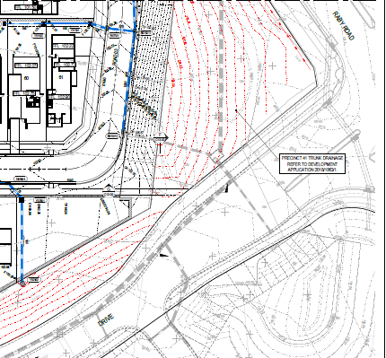
Image 3 – Development plan demonstrating the connection of a pedestrian footpath to the future 2.5m wide footpath within the future entry road

- The proposal might also benefit from consideration of the layout of the development to think through ways it might better relate to its surroundings. For example, the design might make the piazza more functional by incorporating it in a practical pedestrian route or destination. Planning for compatibility with neighbouring development at the El Caballo Blanco site might also assist.

Council Comment
The applicant has amended paths of travel to the central piazza area. The development now provides for a 3m and 4m wide shareway that provides access from Road 01 leading to the piazza and then running parallel upon the western side of the piazza before the shareway connects with Road 04.

The design of the piazza has been reviewed and amended by the applicant and it now contains a children’s playground and community facilities building, including a swimming pool, BBQ’s, a multi-purpose room and amenity facilities.

It is noted that the development site is located nearly 1km north west of the El Caballo Blanco residential development and is separated by a golf course and the Gledswood Homestead site, both which are in separate ownership. The future development of Precincts 3 and 4 of Camden Lakeside will integrate with the development of El Caballo Blanco site in respect to vehicular and pedestrian connections, housing typology and the provision of public open space.

- Consideration of the overlap of the proposed APZs and the backyards is needed.

Council Comment
The application has been amended, with an 8m wide asset protection zone now proposed to be shared within the rear open space areas of lots 6 – 12 and the adjoining Golf Course land.

ASSESSMENT

Environmental Planning and Assessment Act 1979 - Section 4.15(1)

In determining a DA, the consent authority is to take into consideration such of the following matters as are of relevance to the development the subject of the DA:

(a)(i) the provisions of any environmental planning instrument

The environmental planning instruments that apply to the development are:

- State Environmental Planning Policy (State and Regional Development) 2011.
- State Environmental Planning Policy No. 55 – Remediation of Land.
- State Environmental Planning Policy No. 65 – Design Quality of Residential Apartment Development.
- State Environmental Planning Policy (Building Sustainability Index: BASIX) 2004.
- State Environmental Planning Policy (Infrastructure) 2007.
- Sydney Regional Environmental Plan No 20 - Hawkesbury-Nepean River (No. 2 – 1997).
- Camden Local Environmental Plan 2010.

State Environmental Planning Policy (State and Regional Development) 2011 (SRD SEPP)

The SRD SEPP identifies development that is State significant or regionally significant development.

The Panel is the consent authority for this DA as the CIV of the development is $72,762,086. This exceeds the CIV threshold of $30 million for Council to determine the DA pursuant to Schedule 7 of the SRD SEPP.

State Environmental Planning Policy No. 55 – Remediation of Land (SEPP 55)

SEPP 55 requires the consent authority to be satisfied that the site is suitable for its intended use (in terms of contamination) prior to granting consent.

Clause 7 of SEPP 55 requires the consent authority to consider if the site is contaminated. If the site is contaminated, the consent authority must be satisfied that it is suitable in its contaminated state for the development. If the site requires remediation, the consent authority must be satisfied that it will be remediated before the land is used for the development. Furthermore, the consent authority must consider a preliminary contamination investigation in certain circumstances.

Council staff have assessed a contamination assessment of the access road constructed of asphalt and tar leading from Raby Road to the Camden Lakeside Golf Club.

Nine (9) boreholes were drilled within the access roadway. Concentrations of heavy metals and Total Recoverable Hydrocarbons (TRH) were reported below their respective Site Acceptance Criteria (SAC) and no asbestos was detected. TRH concentrations were reported in samples collected from the fill underlying the asphalt but were below the laboratory limits of detection. Douglas Partners within their assessment consider that the identified TRH do not present a human health or ecological risk. Council staff have reviewed the contamination assessment of the access road, agree with its findings and are satisfied that the site is suitable for the proposed development.

State Environmental Planning Policy No. 65 – Design Quality of Residential Apartment Development (SEPP 65)

SEPP 65 aims to improve the design quality of residential apartment development and provides an assessment framework, the Apartment Design Guide for assessing ‘good design’. The SEPP requires consideration of any development application for residential accommodation meeting the application criteria of the SEPP against the nine (9) design quality principles, including the advice obtained from a design review panel and the Apartment Design Guide (ADG). A copy of the assessment of the proposed development against the design criteria and objectives of the ADG is provided as an attachment to this report, with assessment of the application revealing that the development is largely consistent with the ADG and the design quality principles.

The proposed development has been assessed against the SEPP’s design quality principles:

Principle 1: Context and Neighbourhood Character

The surrounding area is undergoing a significant transition as residential subdivision development continues to the east and west of the development site, with the Emerald Hills Neighbourhood Centre already established to the east.

The site is surrounded by Lakeside Golf Club Camden, with the DCP envisaging a series of individual precincts connected by roads and pedestrian pathways surrounded by golf course lands, with future connectivity to the El Caballo Blanco residential development to the south west. The signalised intersection at Raby Road will allow connectivity to the Emerald Hills Neighbourhood Centre and further centres to the east and north of the site.

Whilst residential flat buildings are a new building typology of the area, they are centrally located adjacent to the piazza area and are relatable in human scale through their design, setbacks to the street and building height. The residential flat buildings, including proposed detached housing offer views over the golf course land and positively interact with this adjoining open space by orientating built form towards it, rather than turning its back to it.

The proposed development is considered to result in a positive built form for the future character of the area and will make a positive contribution to the future context. This has been done by achieving and exceeding compliance with the relevant planning controls that will also guide the development of that future character and context.

Principle 2: Built Form and Scale

All proposed residential flat buildings maintain compliance with the maximum height of buildings development standard of 12.5m, proposing 3 storey development, which enables a suitable transition down to two storeys to adjoining detached dwelling houses and a relatable human scale.

The development’s design intent is to create a façade of contemporary terraces overlooking the central piazza area, which is a focal point for social recreation and interaction opportunities.

By satisfying key bulk and scale controls, the development demonstrates that the proposed densities are acceptable and does not result in adverse impacts in respect to overshadowing or loss of visual privacy upon adjoining properties, nor is the development considered to be an unacceptable built form.

The development provides significant setbacks from property boundaries, with horizontal and vertical architectural elements projecting from the main façade to provide articulation and visual interest. The development also accentuates upper balcony ceiling areas through the use of contrasting building materials. Accordingly, the design is considered to be of a high standard and of architectural merit and desirable in this location given its access to the Emerald Hills Neighbourhood Centre.

Principle 3: Density

The development has been designed with a high compliance in key ADG amenity criteria, providing significant areas of communal open space and deep soil zones to allow surrounding areas to be well landscaped and providing a variety of social and recreation areas. The east and west apartment buildings are located adjacent to the central communal piazza area, which is walkable and allows for further social interaction opportunities. The development is within proximity to the Emerald Hills Neighbourhood Centre and will be supported in the future by bus services, enabling connections to other centres.

Principle 4: Sustainability

The proposed development will incorporate a number of sustainability features including solar access and natural ventilation consistent with the ADG objectives, attractive landscaped and usable communal open spaces and compliance with BASIX requirements.
Bicycle storage exists within the development to promote alternative and sustainable transport options to and from and beyond the site.

Principle 5: Landscape

Each apartment building is surrounded with areas of landscaped communal open space and notable deep soil zones, which significantly exceed ADG requirements. The communal open spaces include seating, shelters, and a combination of soft and paved surfaces, providing recreation and social interaction opportunities whilst being overlooked by the proposed apartments for safety and security.

Principle 6: Amenity

The proposed apartments’ layouts and designs are generally compliant with the ADG design criteria and will provide a high level of amenity for future residents, with outlook over the central piazza area and the golf course to the west. A choice of open space opportunities has been provided adjacent to the ground floor, which surround the apartment buildings in the form of turfed areas, landscaped gardens and seating.

Principle 7: Safety

The proposed apartment private open space areas and communal open space areas are well defined and legible, defining which areas are private and for communal use. The proposed buildings provide active frontages to all public roads, including towards the central piazza area maximising passive surveillance opportunities. Controlled access will be provided to the proposed buildings via intercoms swipe cards and remote controllers. Secure resident parking areas will be provided in the proposed basement.

Principle 8: Housing Diversity and Social Interaction

The proposed development will provide a variety of apartment types and sizes, including nine adaptable units and 20% meeting the Liveable Housing Guidelines silver level universal design features. Each apartment building provides a variety of communal open space areas include seating, shelters, and a combination of soft and paved surfaces, providing recreation and social interaction opportunities. The development benefits from further social and recreation spaces within walking distance to the central piazza area and to the Emerald Hills Neighbourhood centre to the east.

Principle 9: Aesthetics

The development provides articulation to all facades, with varying setbacks, including vertical and horizontal architectural elements to provide visual interest to the development. Balcony and private open space areas are grouped together to create a façade of contemporary terraces overlooking the central piazza. A variety of durable, high quality materials are proposed, including lining the ceilings of the upper floor balconies with timber appearance cladding to accentuate this architectural feature from the façade.

State Environmental Planning Policy (Building Sustainability Index: BASIX) 2004

The applicant has submitted a valid BASIX certificate in support of the DA that demonstrates that water, thermal comfort and energy requirements have been achieved.

State Environmental Planning Policy (Infrastructure) 2007 (ISEPP)

The ISEPP aims to facilitate the effective delivery of infrastructure across the State.

Transgrid

Clause 45 – Determination of development applications – other development

The DA was referred to Transgrid for comment pursuant to Clause 45 of the ISEPP as an easement for transmission line exists at the north east corner of the site.

Transgrid raised no objections to the development and recommended compliance with a number of technical guidelines and requirements. A condition requiring compliance with Transgrid’s technical guidelines and requirements is recommended.

RMS

Clause 101 – Development with frontage to classified road

Under clause 101 of the Infrastructure SEPP, the consent authority must not grant consent to development on land that has a frontage to a classified road unless it is satisfied that:

- where practicable, vehicular access to the land is provided by a road other than the classified road, and

- the safety, efficiency and ongoing operation of the classified road will not be adversely affected by the development as a result of:

- the design of the vehicular access to the land, or
- the emission of smoke or dust from the development, or
- the nature, volume or frequency of vehicles using the classified road to gain access to the land, and

(c) The development is of a type that is not sensitive to traffic noise or vehicle emissions, or is appropriately located and designed, or includes measures, to ameliorate potential traffic noise or vehicle emissions within the site of the development arising from the adjacent classified road.

Whilst the development has frontage to Camden Valley Way (i.e. 900 Camden Valley Way), no vehicle access is proposed from Camden Valley Way. Vehicular access will be obtained from an entry road connecting to a signalised intersection from Raby Road. As no vehicle entry points are proposed onto Camden Valley Way for this development, it is considered that the safety, efficiency and on-going operation of Camden Valley Way will not be adversely affected by the development.

Whilst the development is of a type that is sensitive to noise (e.g. residential development), the development is located a significant distance from Camden Valley Way. As such, it is not impacted by this noise source, but rather from Raby Road. Consideration of noise impacts has been made in the application, with construction of an acoustic earth berm along the frontage of the side parallel with Raby Road providing acoustic attenuation to residential dwellings located behind it.

Clause 102 – Impact of road noise or vibration on non-road development

Under clause 102 of the Infrastructure SEPP, the consent authority must not grant consent to development unless appropriate measures to attenuate acoustic noise to the below prescribed internal levels are satisfied:

- in any bedroom in the residential accommodation – 35 dB(A) at any time between 10pm and 7am,
- anywhere else in the residential accommodation (other than a garage, kitchen, bathroom or hallway) – 40 dB(A) at any time.

All lots comply with the above internal noise criteria, with the exception of Lot 27, which is affected by noise from Camden Valley Way and Raby Road. Lot 27 is a single storey development with acoustic fencing provided along its northern and western property boundaries. The proposed fencing will attenuate the ground floor and will result in internal rooms falling below the prescribed internal noise levels as specified in the SEPP.

Clause 104 – Traffic – generating development

The DA was referred to RMS for comment pursuant to Clause 104 of the ISEPP as, pursuant to Schedule 3 of the ISEPP, the development is classed as traffic generating development.

RMS reviewed the application and raised no objection to the development, requesting that seven conditions of consent be included in any consent issued. The conditions recommended by RMS are included in the recommended conditions.

Sydney Regional Environmental Plan No 20 - Hawkesbury-Nepean River (No. 2 - 1997)

SREP 20 aims to protect the environment of the Hawkesbury-Nepean River system by ensuring that the impacts of future land uses are considered in a regional context.

The development is consistent with the aim of SREP 20 and all of its planning controls. There will be no detrimental impacts upon the Hawkesbury-Nepean River system as a result of the development. Appropriate erosion, sediment and water pollution control measures have been proposed as part of the development.

(a)(ii) the provisions of any proposed instrument that is or has been the subject of public consultation under this Act and that has been notified to the consent authority (unless the Secretary has notified the consent authority that the making of the proposed instrument has been deferred indefinitely or has not been approved)

Draft Environment State Environmental Planning Policy (Draft Environment SEPP)

The development is consistent with the Draft Environment SEPP in that there will be no detrimental impacts upon the Hawkesbury-Nepean River system as a result of it.

Camden Local Environmental Plan 2010

There are several aims of Camden Local Environmental Plan 2010. In respect to the proposed development, the following aims of the plan are most relevant:
- to ensure that new communities are planned and developed in an orderly, integrated and sustainable manner and contribute to the social, environmental and economic sustainability of Camden;
- to ensure natural assets within Camden are protected and enhanced;
- to minimise the impact on existing and future communities of natural hazards such as bush fires and flooding; and
- to ensure that appropriate housing opportunities are provided for all existing and future residents of Camden at all stages of their lives and to ensure that the recreation, cultural and social needs of all existing and future residents of Camden are appropriately planned for.

Site Zoning

The site is zoned R1 General Residential, E2 Environmental Conservation and RE2 Private Recreation pursuant to Camden Local Environmental Plan 2010.

Land Use Definitions

The development comprises dwellings, residential flat buildings and roads.

Permissibility

All of the development is permitted with consent in the zones in which it is proposed pursuant to the land use table in CLEP 2010. No works are proposed to occur within the RE2 Private Recreation Zone

Planning Controls

An assessment table in which the development is considered against CLEP 2010 planning controls is provided as an attachment to this report.

Proposed Contravention

The application proposes a contravention to the maximum height of buildings development standard as prescribed under Clause 4.3(2) of Camden Local Environmental Plan (CLEP) 2010. CLEP 2010 limits the maximum height of buildings to 9.5m (J) and 12.5m (M) above ground level (existing) upon this site. Six dwellings upon lots 18, 20, 21, 23, 24 and 25, which are located within the height of buildings map of 9.5m, will breach the development standard. The proposed contraventions range from 365mm to 2.472m.

Contravention Assessment

Pursuant to Clause 4.6(3) of CLEP 2010, the applicant has submitted a written request that seeks to justify the contravention of the development standard. In summary, the applicant’s written request provides the following justification for the contravention:

“The proposed development is an integrated DA, in that it proposes both subdivision works, including bulk earthworks, and the construction of built form i.e. dwellings and residential buildings.

The bulk earthworks involves the contouring of the land to minimize the need for retaining walls and ensure the smoothest transition across the entirety of the precinct.
The site has an area of 6.34ha and is typically described as a gently rolling site comprising a small knoll toward the south and a gully that runs vaguely in an east – west direction from the centre of the site toward the north – western boundary, parallel to Raby Road. This gully is coloured blue and dark green on the extract from the cut and fill plan at Figure 2.

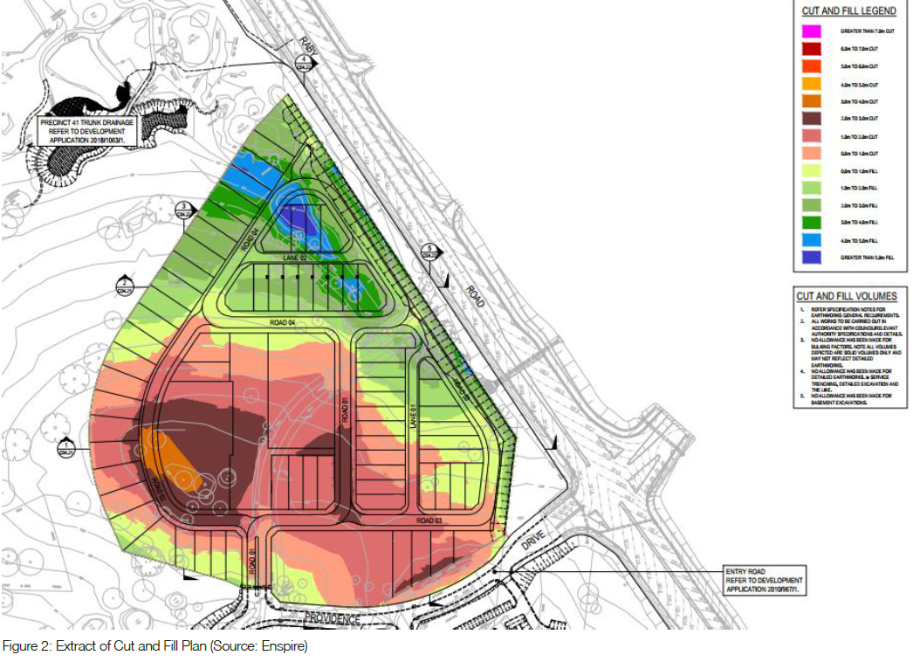

It is the residential lots within the location of the existing gully that technically do not comply with the 9.5m height of building standard, as the bulk earthworks propose between 3 and up to 5m of fill within this narrow gully.

When the height of building is measured from ground level (existing) being the base of the gully i.e. prior to the bulk earthworks occurring and the gully filled, it results in the measurements of the building height being significantly exaggerated due to the inclusion of the fill height. The dwellings themselves are typically 6m in height to the ridge level for a single storey dwelling and approximately 8m to the ridge of a two storey dwelling, when measured from the proposed new ground level. However, when the fill of the gully is taken into account as technically required by the LEP, it results in the two storey dwellings having a non-compliant height within the 9.5m building height limit area, along the western edge of the site. The dwellings that are non-compliant are listed in table 1.

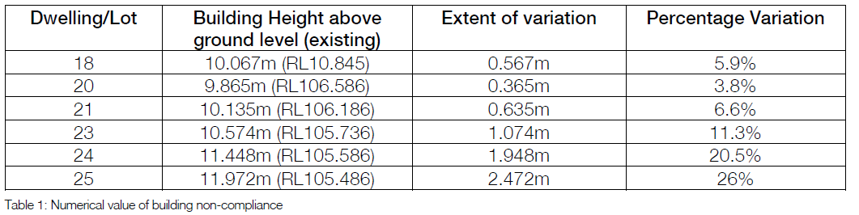

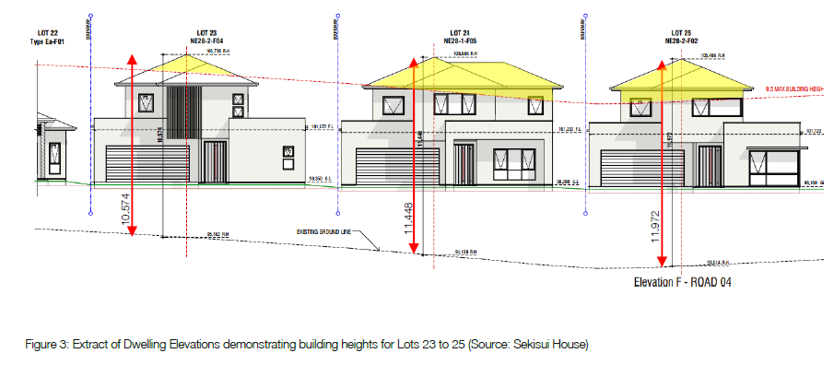

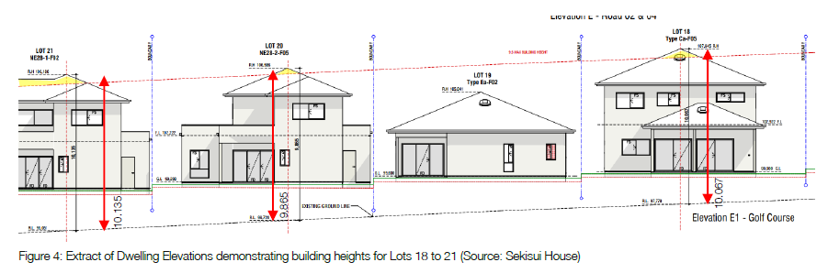

The maximum breach of the height of building standard is by 2.472m by dwelling on Lot 25 which represents a variation to the control by 26%.

Notwithstanding this, this dwelling has an actual building height of 7.586m, when measured from the ground level (proposed). Had it not been for the fill in the gully, these dwellings would readily comply with the height of building control.

A copy of the applicant’s written request is provided as an attachment to this report.

Pursuant to Clause 4.6(4) of CLEP 2010, Council staff are satisfied that:

- the applicant’s written request has adequately addressed the matters required to be demonstrated by Clause 4.6(3) of CLEP 2010, and

- the development will be in the public interest because it is consistent with the objectives of the particular standard and the objectives for development within the zones in which the development is proposed to be carried out.

The development standard contravention is supported for the following reasons:

- the development is consistent with the objectives of the development standard:

- to ensure that buildings are compatible with the height, bulk and scale of the existing and desired future character of the locality.

Despite the height contravention, the building form will still maintain a maximum storey height of two storeys, which is predominately the maximum storey height within adjoining residential subdivisions. In addition, when measured from finished ground levels, the new dwellings will have building heights relative to other dwellings in the neighbouring locality.

- to minimize the visual impact, disruption of views, loss of privacy and loss of solar access to existing development

No view loss, loss of privacy or loss of solar access will occur as a result of the development, noting that the development directly adjoins a golf course where the height contravention occurs. No significant views exist in proximity to the development that require preservation.

- to minimize the adverse impacts of development on heritage conservation areas and heritage items.

The site is located approximately 315m at its closest point to the south from the upper canal, a state listed heritage item and is not located within a heritage conservation area. Accordingly, due to the considerable distance to the upper canal, it is considered that no adverse impacts in respect to view loss, overshadowing or intrusion to curtilage will occur.

- The development is consistent with the objectives for development within the zones in which the development is proposed to be carried out:

R1 General Residential

- To provide for the housing needs of the community

The development provides for zero lot line and detached dwellings and a mix of 1, 2 and 3 bedroom apartments, including nine adaptable units. This contributes to housing diversity and will increase housing choice within Gledswood Hills.

- To provide for a variety of housing types and densities.

The development provides for zero lot line and detached dwellings and a mix of 1, 2 and 3 bedroom apartments, including nine adaptable units to provide for the housing needs of the community.

- To enable other land uses that provide facilities or services to meet the day to day needs of residents.

This objective is not relevant to the proposal, as the proposal provides for residential development only. No land uses for the purposes of providing facilities and services to the public are proposed.

- To allow for educational, recreational, community and religious activities that support the wellbeing of the community.

The development proposes the creation of a central piazza area, which includes a children’s playground and community facilities building, including a swimming pool, BBQ’s, a multi-purpose room and amenity facilities to provide for social and recreational opportunities for residents and their visitors.

- To minimise conflict between land uses within the zone and land uses within adjoining zones.

All development within the R1 General Residential zone is for the purposes of providing residential development and social recreational areas for the benefit of future occupants. As such, no conflict occurs within the R1 General Residential zone.

In respect to the proposed development to the adjoining land zonings of E2 Environmental Conservation and RE2 Private Recreation, the site is predominately surrounded by RE2 Private Recreation, which consists of the Lakeside Gold Club Camden. Lots have been designed to back onto the golf course to enjoy the view across the course, with palisade fencing designed to prevent stray balls entering private open space areas. No access is permitted from adjoining lots to the course, with arrangements made with the owner of the golf course to reconfigure the layout of the course to accommodate a future detention basin to the north to receive and control stormwater flows.

E2 Environmental Conservation land, which runs parallel with Raby Road has been heavily disturbed as a result of Raby Road upgrade works. In addition, a pocket of E2 land located to the south west of the development has also been disturbed through clearing to create a pathway for golfers to reach holes from the clubhouse. Whilst an APZ is proposed within a portion of this E2 Environmental Conservation zone, the existing pathway along the boundary is relatively free of vegetation. As such, minimal clearing for the creation of the required APZ will be required.

E2 Environmental Conservation

- To protect, manage and restore areas of high ecological, scientific, cultural or aesthetic values.

Clause C11.4 of Camden DCP 2011 prescribes areas within Camden Lakeside that are to be protected and rehabilitated subject to Figure C65. As identified earlier within this report, the E2 Environmental Conservation land which runs parallel with Raby Road and which is prescribed to be rehabilitated as per the DCP has been heavily disturbed as a result of Raby Road upgrade works. This section of the adjoining site will be rehabilitated under a separate DA, subject to DA/2018/1063/1.

Figure C65 also identifies an area for vegetation protection upon the neighbouring golf course land, located to the south west. This area is roughly the same area that is zoned E2 Environmental Conservation. Despite Figure C65, it is noted that Environmental Sensitive Land mapping does not strictly correlate with land zoning mapping, with a portion of E2 Environmental Conservation zone land adjoining the development site not mapped as containing sensitive vegetation. Further to this, a perimeter access path has been cleared adjoining the boundary of the development site upon the golf course land, to allow golfers to reach holes from the clubhouse. As portions of the adjoining ‘vegetation protected’ area specified in Camden DCP have been previously removed, proposed protection measures such as palisade fencing from proposed neighbouring lots are considered adequate in protecting this space from the proposed development. The greatest threat to this adjoining vegetation is considered to be from the activities of the golf course in slashing, spraying, fertilizing and maintaining adjoining fairways.
- To prevent development that could destroy, damage or otherwise have an adverse effect on those values.

Palisade fencing is proposed along the perimeter of lots which adjoin the golf course and adjoins a portion of the E2 Environmental Conservation zone, which contains Shale Plains Woodlands. Fencing will prevent unwarranted access through this sensitive vegetation. In addition, all stormwater flows are directed to the north to ultimately flow into a bio retention / detention basin. As such, minimal disturbance is expected upon adjoining sensitive vegetation.

- To protect and enhance the ecology, hydrology and scenic views of waterways, riparian land, groundwater resources and dependent ecosystems.

The adjoining E2 Conservation zone is mapped over sensitive vegetation, rather than waterways and riparian land. The creation of an asset protection zone partially located within the E2 Conservation zone is not expected to significantly impact upon groundwater resources or the localized ecosystem as a perimeter access path, which has cleared vegetation upon the golf course land is located in the area of the required APZ.

- The building height development standard is measured from existing ground levels and does not enable bulk earthworks proposed as part of the application to be taken into account. As such, the proposed height is a consequence of establishing suitable site levels for access, drainage and dwelling construction to fill in an existing natural feature of the site.

- The proposed development will not have any significant impacts on adjoining properties as there will be no additional effect on solar access to the proposed development, adjoining development or upon the public domain.

- The proposed contravention does not result in excessive built form or dwelling height.

It is noted that the Panel may assume the concurrent of the Secretary.

Consequently, it is recommended that the Panel support this proposed contravention to CLEP 2010.

(a)(iii) the provisions of any development control plan

Camden Development Control Plan 2011 (Camden DCP)

Planning Controls

An assessment table in which the development is considered against the Camden DCP is provided as an attachment to this report and any proposed variation are further addressed below:

Dwelling Lots - Front Setbacks

The applicant proposes a variation to front setbacks to two lots (28 and 31), proposing setbacks of 2m (at the closest point) to Lane 02, in lieu of the minimum requirement of 4.5m.

The applicant has provided the following reasons in support of the proposed variation:

The variation proposed on lots 28 and 31 is created where the garage encroaches into the 4.5m setback. This is considered reasonable given that this encroachment occurs on a laneway and that garage setbacks will generally align with rear garages of adjoining lots.

The proposed arrangement of dwellings on lots 28 and 40 will allow for vehicular access, including garages to be contained to Lane 02, while the secondary street (Road 04) will present as the dwelling frontage. This is a deliberate design response to ensure that the structure of Lane 02, including proposed setbacks of garages at lots 28 and 31, are consistent with lots 29-30 and lots 33-39.

Furthermore, the arrangement of dwellings on Lots 28 and 31, including variation to the front setback will ensure:

- Areas of POS are maximized to the north;
- Encroachments are compatible with adjoining development along Lane 02 and assist to reinforce the road hierarchy and associated streetscape they reside within:
- Visual relief and ‘breathing space’ between buildings within the streetscape is achieved and that street planting and landscaping within the verge is not prohibited; and
- Pedestrian and vehicular sightlines are not obstructed.

Due to the location of a landscaped reserve adjoining the curvature of Road 04 to the north of lots 28 and 31, it is considered that the frontage of Lots 28 and 31 is to the southern Lane 02, being the shortest frontage containing direct road access. A 2m setback is proposed to garage elements of both lots, with the remaining façade setback 3.5m from the laneway. The variation is considered acceptable in this instance as the development seeks to maintain a consistent building alignment within the laneway, which is predominately of detached garages setback 0.5m from the property boundary. A much larger or compliant setback of 4.5m would disrupt the harmony of the building alignment within the laneway. Lots 28 and 31 bookend each end of the laneway, providing sightlines to Road 04 and stepping the building form down to reduced setbacks, which laneways encourage via DCP controls.

Secondary Setbacks – Lots >450m²

The applicant proposes a variation to the secondary setback for Lot 40, which proposes a secondary setback of 2.876m to Road 04, contrary to the minimum requirements of 3m.

The applicant has provided the following reasons in support of the proposed variation:

- The encroachment occurring on Lot 40 is considered minor. A small portion of floor space will encroach, however due to the articulation of the dwelling façade along this boundary, the point of encroachment will not dominate the street façade.

Council concurs with the applicant’s justification that the proposed variation is limited to a point encroachment only, with the remaining elements of the development significantly setback from the secondary frontage of Road 04. The stepping of the eastern façade towards the secondary frontage introduces articulation and visual interest to the streetscape, which is encouraged and desired in lieu of straight monotonous walls.

RFBs - Secondary Setbacks

The applicant proposes a variation to the secondary setbacks of Lot 65 (South Apartment) 5.644m and Lot 71 (West Apartment) 5.2m, in lieu of the minimum requirement of 6m.

The applicant has provided the following reasons in support of the proposed variation:

- RFB South and RFB West have minor non-compliances with the 6m setback. These encroachments are considered minor as they relate to portions of balconies and are in locations that will not adversely impact upon the future amenity of surrounding dwellings with respect to overshadowing, privacy or visual impacts. Further, the encroachments into the setback for RFB South will be balanced by the landscaped setback associated with the approved entrance road (DA/2010/967/2).

The proposed breaches to the secondary frontages are considered minor and are limited to point encroachments only, with significant setbacks for the remaining façade. The breaches to the secondary frontages allow each development to introduce articulation and depth to the faced to create visual interest in the streetscape. Accordingly, the minor breaches are not considered detrimental and do not result in amenity impacts such as loss of privacy or overshadowing upon proposed neighbouring development.

Rear Setbacks

The applicant proposes a variation to rear setbacks to Lots 14 (5.839m), 58 (1m), 61 (4.001m) and 66 (1.5m) contrary to the minimum requirements of 6m.

The applicant has provided the following reasons in support of the proposed variation:

- Reduced setbacks to the rear boundary will ensure attractive and cohesive streetscapes are achieved that respond appropriately to the proposed road hierarchy and streetscape;

- The location of garages are appropriately sited to align with setbacks of adjoin built form. Notably the garage on Lot 66 will align with RFB East and garage on Lot 58 and will align with the garage on Lot 57.

- Lot 14 is able to demonstrate compliance with rear setback requirement in Camden DCP 2019.

- The location of garages and dwellings will continue to provide ‘breathing space’ between associated dwellings to make better use of private open space and opportunities for landscaping.

- The encroachment occurring at Lot 14 will not inhibit opportunities across the lot to provide reasonable access to POS, minimum requirements for PPOS, as well as landscaped areas. Further, this lot adjoins the golf course thus minimizing the impact on adjoining impacts.

- The reduced rear setbacks created by garaging, dwelling floor space and architectural elements, will allow for a variety of house types and designs providing articulation and diversity in built form and landscaped outcomes among a variety of streetscapes that reflect proposed road and lane typologies.

Lot 14 (5.839m), which backs onto the neighbouring golf course to the west, is not considered to have any impact upon adjoining development from the marginal numerical non-compliance proposed.

Lots 58, 61 and 66 propose rear setbacks from attached and detached garages to align with setbacks of adjoining development to maintain a consistent building line within the streetscape. In addition, the reduced rear setbacks help achieve in breaking up the facades of the development and providing articulation along the secondary frontages where the garage elements are located upon.

Rear Lane Setbacks

The applicant proposes a variation to rear lane setbacks to lots (28, 29, 30, 31, 33, 34, 35, 36, 37, 38, 39, 42, 43, 44, 45, 46, 47, 48, 49, 50, 51, 52, 54, 55, 56, 57 and 58), which range from 0.5m to 2.1m within Lanes 01 and 02, contrary to the minimum requirements of 2.5m.

The applicant has provided the following reasons in support of the proposed variation:

- A number of encroachments occur due to the location of garages at the rear boundary of rear loaded lots however all rear lane garages currently non-compliant with the 2.5m required setback will comply with Council’s Draft DCP 2019, which prescribes the following control for rear lane setbacks:

1m.

Notwithstanding this, the rear lane setback can be reduced to 0.5m only if it can be adequately demonstrated to Council’s satisfaction, that the development can facilitate waste collection in a safe an orderly manner.

Where the proposal is unable to meet the 2.5m rear lane setback control, the proposal is able to demonstrate compliance with the minimum rear lane setbacks established under the Draft DCP 2019.

In the circumstances of those rear loaded lots, having garages setback to 2.5m along this rear boundary would result in the creation of ‘dead space’ dominated by the driveway. The proposed garage setbacks allow for this space to instead be located centrally within the lot where it is more appropriately connected to the dwelling as private open space. Further, the function of the proposed setback to garages has the intended effect of removing opportunities for vehicles to park across the verge and within the rear setback.

With regards to waste collection, where reduced rear setbacks occur along Lane 01 and Lane 02, building separation in excess of 9.3m will be achieved, ensuring clearance to dwelling structures. Furthermore, in both occasions, laneway width will be 6m to accommodate two way traffic. No parking is proposed along both lanes. Bin collection areas will be available for each dwelling encompassing space within the verge.

Despite the non-compliance, the reduced rear lane setbacks from detached garages to Lane 01 and 02, do not diminish the ability to collect waste, as the width of the lot allows bins to be located adjacent to these structures. The reduced rear lane setbacks proposed are consistent with rear lane setback controls within the Growth Centre Precincts and other areas within the Local Government Area, which seek to eliminate depth behind structures for vehicles, boats and trailers to be stored across the verge of the laneway. It is considered desirable to reduce the rear lane setback to maximise and increase the area of private open space, which is located between the dwelling house and detached garage. Given the orientation of the lanes, this also ensures that solar access is maximized to a greater area of the private open space.

Zero lot line

The applicant proposes a variation to the maximum depth for zero lot development for nine lots (2, 3, 29, 31, 59, 60, 66, 67 and 68) which varies from 0.4m to 4m greater than the maximum depth of 10m.

The applicant has provided the following reasons in support of the proposed variation:

- Proposed wall lengths will ensure the efficient use of each lot is achieved, particularly accommodating the minimum requirement for car parking, without garages dominating the dwelling façade and streetscapes.

- Increased wall length will have no adverse impact upon adjoining properties, including access to sunlight, privacy and amenity.

- Increased wall length will allow for greater diversity on housing across the site and articulation in the streetscape; and

- Minimum setback requirements on adjoining lots for servicing are achieved without prohibiting access across the lot, landscape area, private open space and principal private open space.

Variation Assessment

Of the nine breaches to this development control, seven lots propose a tandem garage. The use of tandem garages and subsequent breach of zero lot length as a result is supportable, as tandem garages offer diversity in the streetscape in providing a single garage door in lieu of a double garage door dominating the streetscape. In addition, as zero lot development occurs adjacent to side boundaries, there is limited visual and amenity impacts from exceedances.

Landscaping

The applicant proposes a variation to minimum landscaping requirements, with lots 33, 35, 37 and 39 providing a landscaped area of 26% (of the sites area) in lieu of the minimum DCP requirements of 30%.

The applicant has provided the following reasons in support of the proposed variation:

- The reduced landscape area across these lots is largely due to the lot design and change in levels, including the location of retaining walls separating the dwelling and garage. Across these lots, due to the space restrictions, as well as water and maintenance requirements, turf as a ground treatment, along with permeable gravel spaces has been proposed. This solution meets the aims and objectives of the DCP in regard to deep soil and permeability for water runoff, whilst providing residents with a robust, versatile private open space area. The structure of the gardens allow for planting to permeate and grow through the gravel areas, whilst feature trees provide soft shading of the spaces.

Lots 33, 35, 37 and 39 have a primary frontage to Road 04, with detached garages separated by a retaining wall facing the northern lane 02. As a result, these lots marginally fail to achieve the minimum landscaped area for the site from additional impervious areas to address topography issues. Despite the non-compliance, each lot satisfies the minimum principal private open space area and solar access requirements. The marginal non-compliance is not expected to diminish the ability of each lot to provide suitable landscaping, with landscaping across the entire development considered to be of a high quality with a preference for natives, which are generally drought tolerant.

Solar Access to Principal Open Space

The applicant proposes a variation to the solar access requirements to areas of principal private open space to lots 4, 5, 54 and 63. These lots receive less than the minimum requirement of 2 hours to at least 50% of the principal private open space area. Lot 63 will receive one hour of solar access from 10am to 11am, however lots 4, 5, and 54 will receive no solar access, as overshadowing to areas of principal private open space is greater than 50% throughout the day.

The applicant has provided the following reasons in support of the proposed variation:

- Those lots equate to less than 10% of all dwellings across the site;

- Lots 4, 5, 54 and 63 are challenged by their north, south orientation and Council’s requirements for POS and PPOS to be placed behind the building line;

- These lots are able to demonstrate compliance at both Autumn and Spring equinox;

- These lots will continue to meet the objective of this control in that the dwellings will: continue to provide a high level of residential amenity with opportunities for outdoor recreation and relaxation within the property and will ensure that each site has sufficient area for landscaping, including deep soil planting areas for larger trees, to facilitate the establishment of attractive and functional open space areas;

- Dwelling design has been undertaken to ensure that overshadowing of adjacent properties is minimized to ensure adjoining dwellings are readily able to achieve solar access; and

- Lot 4, 5, 54 and 63 will achieve areas of PPOS in excess of the minimum 20% ranging from 24.8% to 35.2%.

Of the 69 dwellings proposed, only 4 dwellings fail to receive the required solar access to areas of principal private open space, with some lots receiving an hour or slightly greater and others nil. This is not the result of a poor subdivision layout, but as a consequence of the northern orientation of the site. The northern orientation of the site determines that east / west roads are required to connect to north / south roads, with lots located on the southern side of east / west roads overshadowing their own development. Unless such lots are designed to be single storey in height, there is limited opportunity in this instance to ensure that all development can receive 2 hours of solar access to principal open space areas. Each of the non-complying lots has significant private open space area and is able to receive solar access during warmer months of the year, when the use of private open space is more prevalent.

Density

The applicant proposes a variation to the residential density requirements for residential flat building development and within Camden Lakeside. The applicant proposes three residential flat buildings that will have the following densities:

- South Apartment (Lot 65) 136.7m² per dwelling,
- East Apartment (Lot 70) 117.1m² per dwelling, and
- West Apartment (Lot 71) 132.3m² per dwelling, which are contrary to the maximum density of 1 dwelling per 200m² envisaged by Camden DCP 2011.

The applicant has provided the following reasons in support of the proposed variation:

- The objectives of Section C11.1 of the DCP include: Establish a framework for the provision of a diversity of dwelling types, including options for seniors living, multi dwelling housing and residential flat buildings in Precinct 1. Accordingly, the proposed design of Precinct 1 includes provision for three (3) RFBs. Not only is this in line with the objectives for Precinct 1 of Camden Lakeside but it is also compliant with the land use permissibility of the R1 General Residential zone.

However, the density control imposed for RFBs is not conducive to this objective and the emerging urban environment envisaged for this part of Camden Lakeside and the wider Camden LGA. Particularly having regard to sites proximity to Emerald Hills Neighbourhood Precinct, Raby Road and Camden Valley Way.

Further, this density control fails to promote the construction of residential flat buildings when the LEP allows for dwellings on lots as small as 250m². The minor differentiation between these two (2) density outcomes significantly reduces any incentive for RFB construction.

The dwelling densities proposed for RFB’s across the site will ensure the design outcomes for Precinct 1 comply with the objective to deliver provision for a diversity of dwelling types. Further, the design and proposed densities of RFBs will achieve compliance with the 50% site coverage control. Each of the RFBs sit within generous landscaped grounds with communal open spaces and deep soil zones well in excess of the SEPP 65 / ADG requirements.

Given the proposed provision of communal open space and deep soil on the three (3) RFBs, it demonstrates how onerous this one (1) apartment per 200m² site area control is. The DCP control is inconsistent with the delivery of higher density housing as anticipated by the land use zoning applicable to the site and the three (3) storey height control and the specific DCP controls which encourage RFBs within this Precinct.

In fact, it could be argued that the current density control for RFBs under the DCP, is incompatible with the provisions of the SEPP 65/ADG and the LEP and should have no effect pursuant to section 3.43(5) of the EP&A Act, 1979.

The development of the first stage of the Camden Lakeside Precinct is located within the R1 General Residential zone, which permits a variety of dwelling forms, including residential flat buildings. The variety of dwelling forms proposed is consistent with the objectives of the R1 General Residential zone, specifically to provide for a variety of housing types and densities.

As noted within the applicant’s justification, the density control of 1 unit per 200m² is prohibitive in constructing residential flat buildings, when you compare that the minimum dwelling lot size within Camden Lakeside is 250m² and the minimum internal areas for residential units ranges from 50m² for a 1 bedroom unit to 90m² for a 3 bedroom unit as per Apartment Design Guide. To achieve a compliant density for 30 apartments, the lot would need to be a minimum of 6000m², with the resultant building form unlikely to promote the orderly and economic use and development of land.

The development plans demonstrate that the proposed densities are acceptable, with compliant heights, site coverage, with significant setbacks proposed to property boundaries, and communal open space (ranging from 21.5% to 46.7%) and deep soil areas (ranging from 17.9% to 34.5%) also significantly exceeding ADG requirements.

By satisfying the key bulk and scale controls, the development demonstrates that there is a disparity between the density controls of Camden DCP 2011 and Camden LEP 2011 and the Apartment Design Guide, which is a guide for assessing ‘good design’.

In addition, the residential flat buildings are located in proximity to the Emerald Hills Neighbourhood Centre and will eventually be supported with bus services to allow access to centres beyond the site. The R1 – General Residential zoning envisages a variety of land uses, including residential flat buildings, which could be up to three storeys in height. The location of such development is preferred to be located with good access to Town Centres and public transport.

It is further noted that the density control as it relates to residential flat buildings is no longer contained in Camden DCP 2019.

Consequently, it is recommended that the Panel support the proposed variations to the Camden DCP.

(a)(iiia) the provisions of any planning agreement that has been entered into under section 7.4, or any draft planning agreement that a developer has offered to enter into under section 7.4

The proposed development site is subject to the terms and conditions of the Camden Lakeside Planning Agreement executed between Camden Council and SH Camden Lakeside Pty Limited, dated 10 July 2020.

The terms of the voluntary agreement require the developer to provide a monetary development contribution. Based on lots within Precinct 1, a monetary contribution figure has been calculated and is included within the recommended conditions.

(a)(iv) the regulations (to the extent that they prescribe matters for the purposes of this paragraph)

The Environmental Planning and Assessment Regulation 2000 prescribes several matters that are addressed in the conditions attached to this report.

(b) the likely impacts of the development, including environmental impacts on both the natural and built environments, and social and economic impacts in the locality

As demonstrated by the assessment, the development is unlikely to have any unreasonable adverse impacts on either the natural or built environments, or the social and economic conditions in the locality.

(c) the suitability of the site for the development

As demonstrated by the above assessment, the site is considered to be suitable for the development.

(d) any submissions made in accordance with this Act or the regulations

The DA was publicly exhibited for a period of 14 days in accordance with Camden Development Control Plan 2011. The exhibition period was from 14 September 2018 to 27 September 2018 and one objection and one submission in support was received.

Following the submission of amended plans and additional information, the DA was publicly re-exhibited for a period of 17 days in accordance with Camden Development Control Plan 2019. The re-exhibition period was from 7th January 2020 to 24th January 2020 and one objection and one submission in support was received. The submission of objection against the proposed development was later withdrawn.

(e) the public interest

The public interest is served through the detailed assessment of this DA under the Environmental Planning and Assessment Act 1979, the Environmental Planning and Assessment Regulation 2000, environmental planning instruments, development control plans and policies. Based on the above assessment, the development is consistent with the public interest.

EXTERNAL REFERRALS

The external referrals undertaken for this DA are summarised in the following table:

External Referral | Response
NSW Rural Fire Service. | No objection and a Bush Fire Safety Authority granted.
RMS | No objections and recommended conditions issued.
Transgrid | No objections and recommended conditions issued.
Sydney Water. | No objection.
Camden Police | No objection.

Conditions that require compliance with the Bush Fire Safety Authority and external referral recommendations are included in the recommended conditions.

FINANCIAL IMPLICATIONS

This matter has no direct financial implications for Council.

CONCLUSION

The DA has been assessed in accordance with Section 4.15(1) of the Environmental Planning and Assessment Act 1979 and all relevant instruments, plans and policies. The DA is recommended for approval subject to the conditions attached to this report.

RECOMMENDED
That the Panel:

- support the justification in the applicant’s written request lodged pursuant to Clause 4.6(3) of Camden Local Environmental Plan 2010 to the contravention of the height of buildings development standard, and

- approve DA/2018/969/1 for demolition of the existing entry road, community title subdivision to create 73 lots (69 dwelling lots, three superlots for the residential flat buildings and one community lot for the park), construction of 69 dwellings and three residential flat buildings containing 90 apartments, associated earthworks, construction of local roads, drainage works, neighbourhood park / piazza, including community facilities (pool, community building, BBQ and childrens playground) landscaping works and acoustic upgrade works to Lakeside Golf Club Camden subject to the conditions attached to this report.

